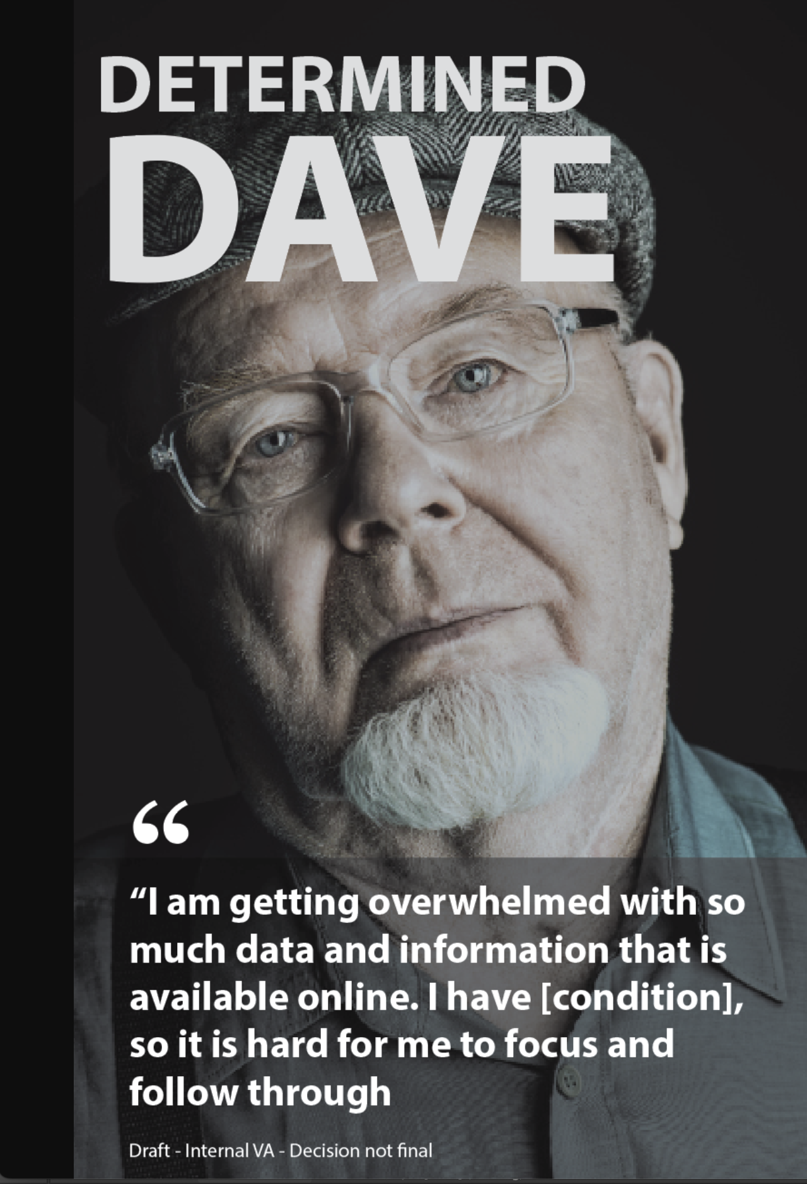**Dave’s Flow**

Scenario: **User dials 1-800- 827-100 to the Call Center using the smartphone keypad. User hears the Male IVR**

**IVR:** *Welcome to the Department of Veteran Affairs Telephone Assistance Service.*

*For V.A. information via the internet,*

*please visit our website at*

*www.v a.gov.*

*If you are having thoughts of suicide,*

*press 7 now to be connected with the veteran’s crisis line,*

*or you may call 1-800-273-8255,*

*and then press 1.*

*if you are calling to enroll in direct deposit or to update your existing direct deposit information,*

*please consider making this change at v a.gov.*

*The v a.gov website is the fastest and most secure method to update your direct deposit information*

*Para Español, oprima numero dose*

*We're exploring ways to improve our call services. You can help by trying our new voicebot assistant today.*

*Our voicebot can help with your questions about your claims status and the new PACT Act law.*

*To try the voicebot, select 7.*

*To continue with our regular call menu options, select 8.*

*User presses the number seven on the phone keypad.

**Voice Bot:***Thanks for trying out this new way to get help.*

To get started, ask me a question like “What’s my claim status?” or “What does the PACT Act do for Veterans like me?”

*At any time, you can still get to a call center agent.*

*I can help with information related to claims status and PACT Act.*

*Please tell me what I can help you with today?* **Pause (01:40)**

**Dave:** *Yeah, I submitted my disability claim, and I don't understand what's going on with it*

**Voice Bot:** *I understand you want to know about your claim status. First, let me verify some information for security purposes.*

*Can you please provide me with the last four of your social security number?*

**Dave:***The last four of my social is 2 4 6 8.*

**Voice Bot:** Thank you for verifying your information, Dave. I see one open claim in your account which was filed on June 6th, 2022 and is currently under initial review. This means that we’ve assigned a representative to your claim who will gather all of the evidence we need to make a decision on your claim. We’ll notify you by mail if there’s any additional information that is needed. **Pause (02:30)**

**Dave:** Okay... but why is it taking so long

**Voice Bot:** I apologize for the length of time that it is taking to process your claim; however, we are currently experiencing a backlog of claims and are working to get them decided as quickly as possible. Would you like me to send you a link with more information about the claims process?

**Dave:** Sure.

**[VB Authentication]**

**Dave:** Yes, that is my phone number.

**Voice bot:** Okay, Dave. I've sent a text to the number associated with your account, ending in 5309.

 If you think you’re eligible for VA health care and benefits, we highly encourage you to apply now. Is there anything else I can help you with?

**Dave:** No, that's it.

**Voice bot:** Thanks for calling the Department of Veterans Affairs. Have a great day

>>>>>>>>>>>>>>>>>>>>> END DAVE’S FLOW <<<<<<<<<<<<<<<<<<<<<<<<<<<<<<<

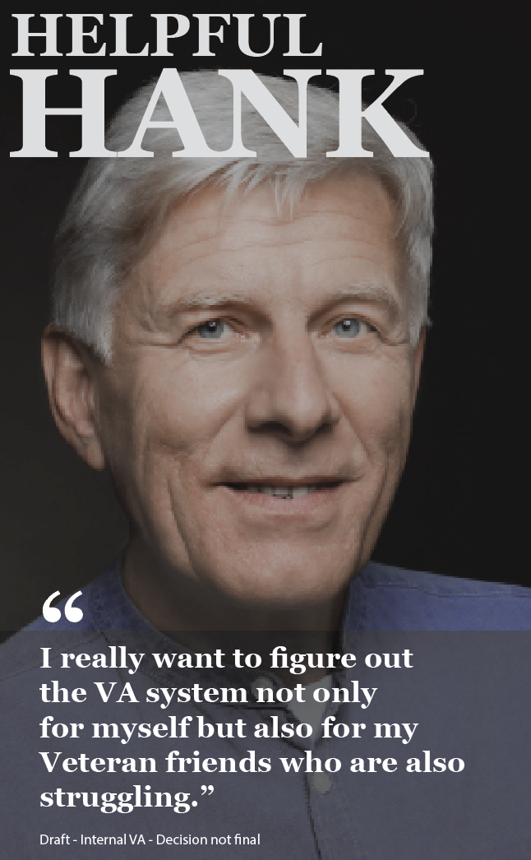

**Hank’s Flow**

**[VB Welcome Message]**

**User:** *I'm thinking about filing a claim since the PACT Act was passed, but I don't know what a presumptive condition is and if I have one.***Pause (0:22)**

**Voice bot:** *I understand you want to know about presumptive conditions under PACT Act. For some conditions, we automatically assume that your service caused your condition, and this is what we call a "presumptive condition."*

*If you have a presumptive condition, you don’t need to prove that your service caused the condition; you only need to meet the service requirements for the presumption.*

*A list of new presumptive conditions under PACT Act is on VA.gov. Would you like me to send you a link via text?*

**Hank:** *Sure.*

**[VB Authentication]**

**Hank:** *Yes That is my phone number.*

**Voice bot:** *Okay, Dave. I've sent a text to the number associated with your account, ending in 7707.*

*If you think you’re eligible for VA health care and benefits, we highly encourage you to apply now. Is there anything else I can help you with?*

**User:** *No, that's it*.

**Voice bot:** *Thanks for calling the Department of Veterans Affairs. Have a great day.*

>>>>>>>>>>>>>>>>>>>>> END HANK’S FLOW <<<<<<<<<<<<<<<<<<<<<<<<<

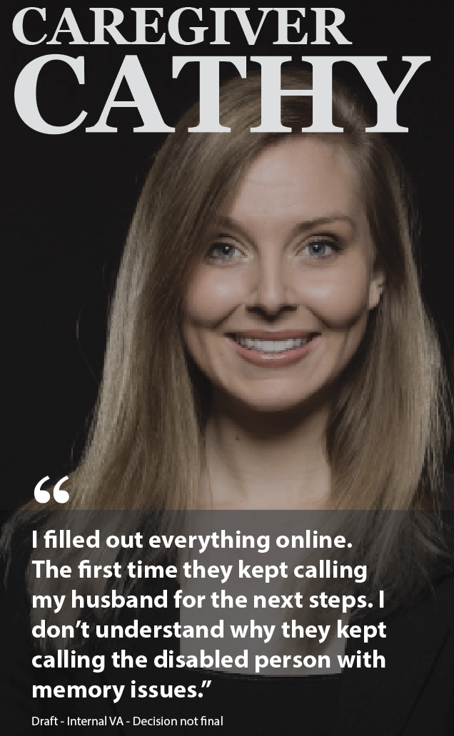

**Cathy’s Flow**

**[VB Welcome Message]**

**Cathy:** *Hi, my husband recently started a disability claim, but he has a condition that he can't include in the form....* **Pause (00:18)**

**Voice Bot:** *I'm having some difficulty understanding what you are asking. Can you try again?*

**Cathy:** *I just need some help with my husband's disability claim*.

**Voice Bot:** *Currently, I am not able to assist caregivers with a Veteran's claim, but I can transfer you to a call center agent who will be able to help. Would you like to be connected now?*

**Cathy:** *That's fine*

**Voice Bot:** *One moment please...*

>>>>>>>>>>>>>>>>>>>>> END CATHY’S FLOW <<<<<<<<<<<<<<<<<<<<<<<<<